Jeremy Bowne

CIS224

Professor Binder

12/6/2018

Final Project - Microsoft Project

**Information Security “Pentesting” Web Application**

**SCOPE:**

A new company with a full featured web application in which other companies/corporations can test their own systems against unauthorized intrusions with. Application would attempt various exploitation code to see if there are any holes in the customer’s network and would then list a series of fixes that they could then employ through a process called “pentesting”. Some of the features would be for programmers to then be hired as contractors for these repairs/system modifications. This project details many aspects of setting up an office, hardware, and then falls into line with the SDLC (Software Development Lifecycle).

Many of the phases of this project run on a Start-To-Finish timeline, except for documentation which will be updated throughout the entirety. The planning stage will be mostly done by senior IT staff, which includes the renowned video-game programmer John Carmack. Since this project will eventually be handed off to a solid maintenance team after the deployment stage there is a solid deadline of 4/27/2019 which allows for a few days of lag time.

**GOALS:**

1. Using a team with expertise in computer security and other applicable fields, create a web-application that automates the process of pentesting various servers in an easy to use GUI.
2. Don’t reinvent the wheel, use API’s (Application Programming Interfaces) which link to other (non-web-application) programs that have a solid database of security flaws to test.
3. Have bug-free code and great documentation so that this web application doesn’t fall into the long list of others that become what they set out to prevent.

**ASSUMPTIONS:**

1. This will be profitable.
2. The applications linked to ours can coexist.
3. This has already been done, but we can do it better.

**Snips:**

**“Sorting” (By Cost High to Low)**

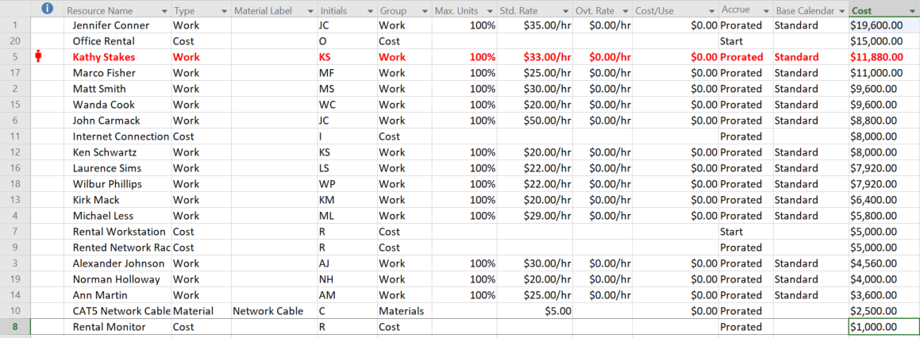

**“Grouping” (Resource Group by Cost)**

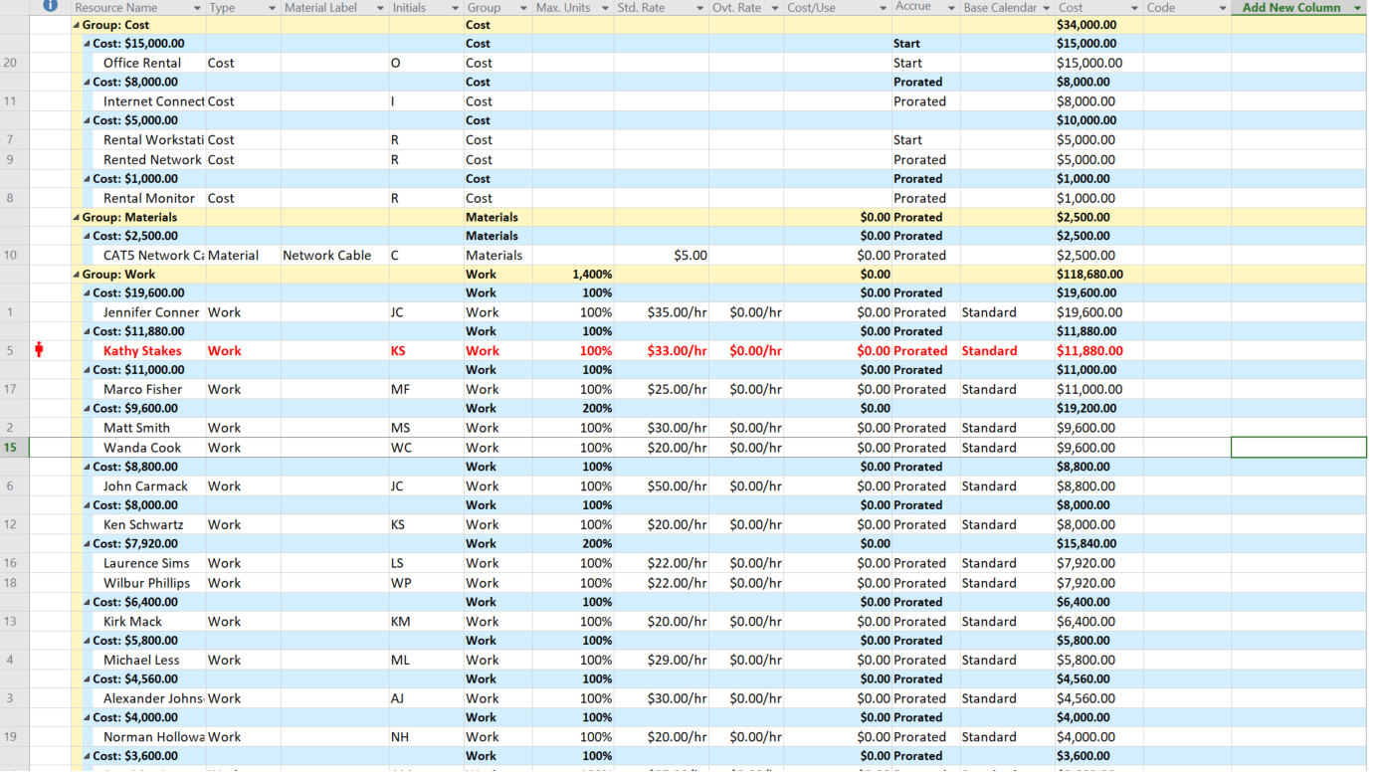

**“Filtering” (By Completed Tasks)**

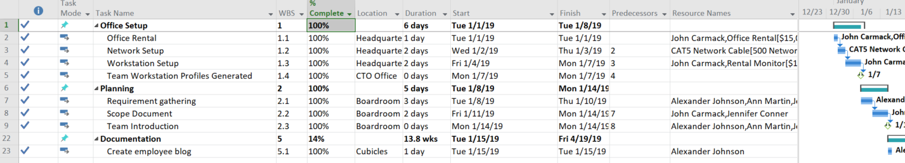

**Evidence of Baseline**

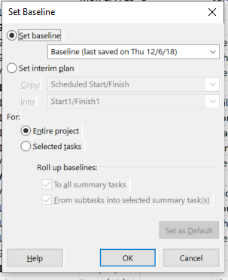

**Cost Report**

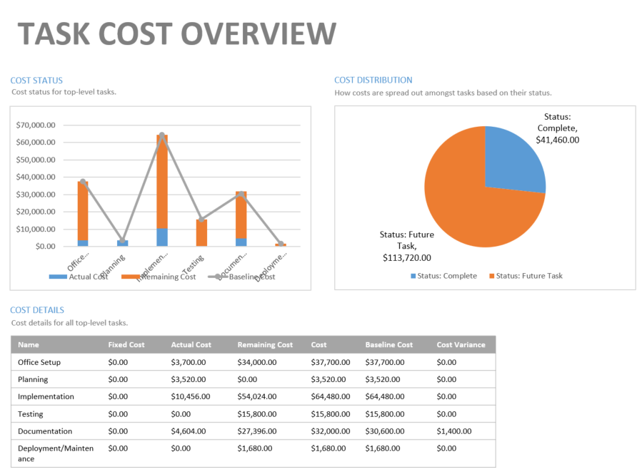

**Resource Report**

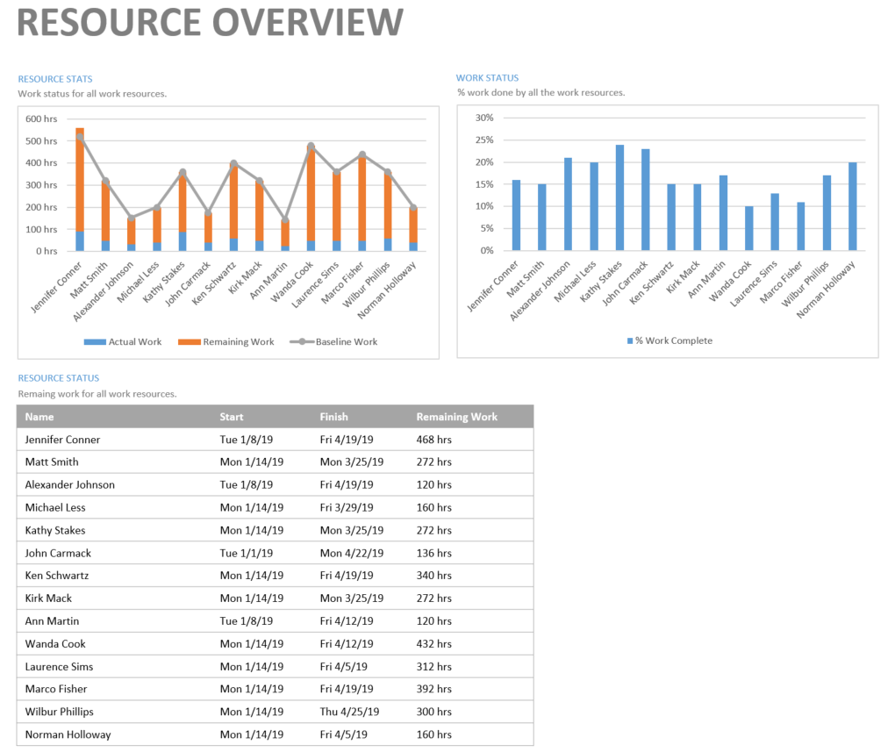

**Dashboard**

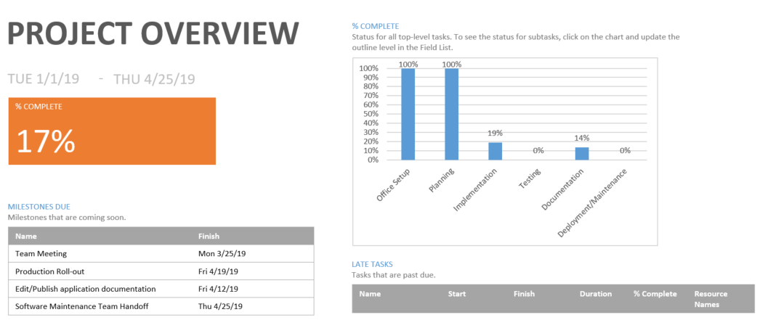

**Identity of Resource Personalized Calendar**

Michael Less is having a heart transplant, but feels he only needs a few days off work afterwards. His work ethic sometimes outdoes his health choices, but he constantly repeats the moto “Sometimes Less is More”. Security Web-Applications™ is willing to take the risk for some reason.